# Auto-following function

## The sensor used by the auto-following vehicle is the same as the obstacle avoidance vehicle.

## Install the auto-following vehicle

|  |  |
| --- | --- |
| SSJY2-01 套件 蹦蹦 赛车形态_空白视图 2_42 | SSJY2-01 套件 蹦蹦 赛车形态_空白视图 2_43 |
| SSJY2-01 套件 蹦蹦 赛车形态_空白视图 2_44 | SSJY2-01 套件 蹦蹦 赛车形态_空白视图 2_45 |
| SSJY2-01 套件 蹦蹦 赛车形态_空白视图 2_46 | SSJY2-01 套件 蹦蹦 赛车形态_空白视图 2_47 |
| SSJY2-01 套件 蹦蹦 赛车形态_空白视图 2_48 | SSJY2-01 套件 蹦蹦 赛车形态_空白视图 2_49 |
| SSJY2-01 套件 蹦蹦 赛车形态_空白视图 2_50 |  |
|  | |

## Infrared obstacle avoidance sensor controls LED

Place the packaging box at different distances in front of the front wheel of the vehicle and record the values of the obstacle avoidance sensor.

When the value of obstacle avoidance sensor changes, the brightness of LED changes.

1. Example program

|  |
| --- |
|  |

1. **Experiment phenomenon**

The LED lights up, and then gradually approaches in front of the obstacle avoidance sensor on the left with your hand. You can see that the brightness of the LED light will also decrease.

1. **Record values for different distances**

Place the packaging box or other relatively flat objects 5 cm in front of the front wheel of the vehicle, record the values measured by the infrared obstacle avoidance sensors on both sides, then record the values placed at a distance of 10 cm, and then record the values placed at a distance of 40 cm.

These values are recorded to prepare for auto-following vehicle.

The values in the table below are the values I measured. The values of each sensor are different. You must measure them yourself.

|  |  |  |  |
| --- | --- | --- | --- |
|  | Distance of 5cm | Distance of 10cm | Distance of 40cm |
| Left obstacle avoidance sensor | 548 | 655 | 810 |
| Right obstacle avoidance sensor | 552 | 660 | 814 |

## Straight following vehicle

From the previous section, we know the values of several different distances of obstacles, as shown in the following table.

|  |  |  |  |
| --- | --- | --- | --- |
|  | Distance of 5cm | Distance of 10cm | Distance of 40cm |
| Left obstacle avoidance sensor | 548 | 655 | 810 |
| Right obstacle avoidance sensor | 552 | 660 | 814 |

We want to realize the straight following function, that is, the vehicle can move forward, stop and back with the object in front.

1. **Program idea**

|  |  |  |
| --- | --- | --- |
| Left obstacle avoidance sensor value  val\_left | Right obstacle avoidance sensor value  val\_right | Movement of the vehicle |
| 655<val\_left <810 | 660<val\_right <814 | Forward |
| 548<val\_left <655 | 552<val\_right <660 | Stop |
| val\_left <548 | val\_right <552 | Backward |
| val\_left > 810 | val\_right > 814 | Stop |

1. **Example program**

|  |
| --- |
|  |

|  |
| --- |
|  |

1. **Experiment phenomenon**

Place the packaging box in front of the vehicle, move the packaging box forward and backward, and the vehicle will move forward, stop and back.

## Multi-direction following function

The following function is a necessary function for automatic driving. Following is not only a straight following, but also a turn. In this lesson, we will realize a simple turnable following function.

1. **Program idea**

|  |  |  |  |
| --- | --- | --- | --- |
|  | Distance of 5cm | Distance of 10cm | Distance of 40cm |
| Left obstacle avoidance sensor | 548 | 655 | 810 |
| Right obstacle avoidance sensor | 552 | 660 | 814 |

Then take 700 on both sides as the value to follow the left and right turns.

|  |  |  |
| --- | --- | --- |
| Left obstacle avoidance sensor value  val\_left | Right obstacle avoidance sensor value  val\_right | Movement of the vehicle |
| 655<val\_left <810 | 660<val\_right <814 | Forward |
| 548<val\_left <655 | 552<val\_right <660 | Stop |
| val\_left <548 | val\_right <552 | Backward |
| val\_left > 810 | val\_right > 814 | Stop |
| val\_left > 700 | val\_right < 700 | Turn left |
| val\_left < 700 | val\_right > 700 | Turn right |

1. **Example program**

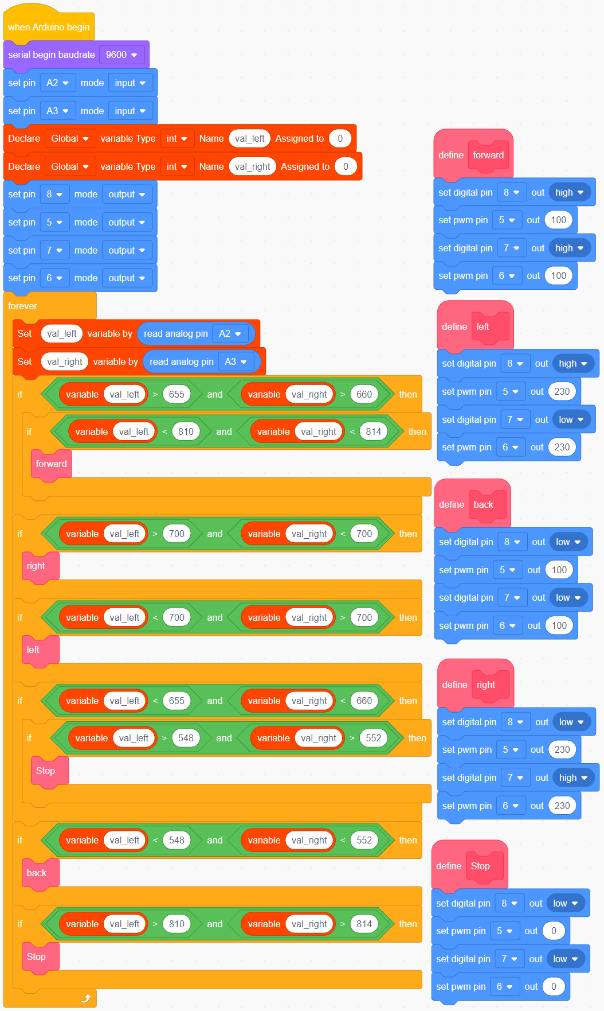

1. **Experiment phenomenon**

Place the packaging box in front of the vehicle and slowly move it back and forth, left and right, and the vehicle moves back and forth, left and right.